SIMATS ENGINEERING
ASSESSMENT TOOL 3

COURSE NAME: Database Management Systems
COURSE CODE: CSA05

COURSE OUTCOME COVERED

CO2: Apply the relational model, relational algebra, SQL query structures, and views to solve database querying and data manipulation problems. (BL3, BL6)

Activity Tool : Debugging & Optimisation Task (Low)
Assessment Tool Weightage: 30%

Dr

QUESTIONS Total Marks: 50
Q.No | Question | Bloom's Level | Marks
1 | Identify and fix the error in the given SQL query that uses incorrect JOIN syntax and returns duplicate results. | BL3 – Apply | 5
2 | The following sub-query returns incorrect results due to a missing correlation. Debug and rewrite it correctly. | BL3 – Apply | 5
3 | A given SQL view definition causes errors when queried. Identify the issue and rewrite a correct and optimized view. | BL3 – Apply | 5
4 | Debug the given relational algebra expression that produces incorrect output for a natural join operation. | BL3 – Apply | 5
5 | The SQL query below violates referential integrity. Identify the violation and modify the statements to enforce proper constraints. | BL3 – Apply | 5
6 | Given an inefficient SQL query with nested loops, rewrite it using JOIN to optimize performance. | BL6 – Create | 5
7 | The GROUP BY query below produces wrong aggregation results. Debug the query and explain the error. | BL3 – Apply | 5
8 | Identify and fix the logical error in a given SQL UPDATE statement that unintentionally modifies all rows in the table. | BL3 – Apply | 5
9 | Optimize the given multi-table SQL query by restructuring sub-queries into JOINs and using appropriate indexes. | BL6 – Create | 5
10 | Debug a given relational calculus expression that returns an empty result set due to incorrect quantifier usage. | BL3 – Apply | 5

Code of Conduct:
S Sayed Sahil (192525397)
I ____________________ (Name / Reg No) certify that this submission is my original work and that I have adhered to the guidelines specified for this assessment.
I understand that any violation of academic integrity rules will result in disciplinary action.

Signature of the student:

RUBRICS FOR CALCULATION:

Criteria | Weightage | Level 4 (Exemplary) | Level 3 (Proficient) | Level 2 (Developing) | Level 1 (Beginning)
Problem Identification | 20% | Accurately identifies all errors and root causes with clear understanding | Identifies most errors with minor gaps | Identifies some errors but misses key issues | Unable to identify errors correctly
Debugging | 25% | Applies systematic debugging techniques effectively to resolve issues | Uses appropriate debugging methods with minor errors | Limited debugging approach; requires guidance | Unable to debug or resolve issues
Optimization | 20% | Optimizes code by significantly improving time complexity using efficient algorithms | Improves time complexity with minor gaps in efficiency | Limited improvement in time complexity | No improvement; inefficient approach retained
Analysis | 20% | Demonstrates strong logical reasoning and clear justification of solutions | Shows reasonable analysis with some justification | Limited analysis; weak reasoning | No analytical reasoning demonstrated
Code Quality | 15% | Produces clean, well-structured code with proper comments and documentation | Code is mostly clear with minor documentation gaps | Code lacks structure and proper documentation | Poorly written code with no documentation

1. Incorrect JOIN Syntax Returning Duplicate Results

-- Incorrect Query
SELECT *
FROM Student s, Course c
WHERE s.CourseID = c.CourseID;

-- If duplicate rows occur because of multiple matching records,
-- use proper JOIN syntax and DISTINCT if needed.

-- Correct Query
SELECT DISTINCT s.StudentID, s.StudentName, c.CourseName
FROM Student s
INNER JOIN Course c
ON s.CourseID = c.CourseID;

Explanation:
- Replaced old-style join with INNER JOIN.
- Used DISTINCT to remove duplicate records if required.

OUTPUT :
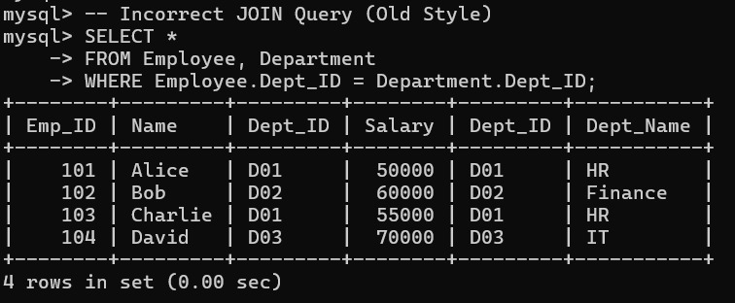

2. Subquery Missing Correlation

-- Incorrect Query
SELECT StudentName
FROM Student s
WHERE Marks > (
SELECT AVG(Marks)
FROM Student
);

-- Correct Correlated Query
SELECT s.StudentName
FROM Student s
WHERE s.Marks >
(
SELECT AVG(s2.Marks)
FROM Student s2
WHERE s2.DepartmentID = s.DepartmentID
);

Explanation:
- The subquery is correlated with the outer query using DepartmentID.
- Compares each student with the average marks of their department.

OUTPUT :
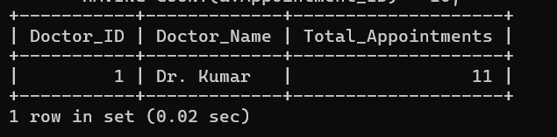

3. Incorrect SQL View Definition

-- Incorrect View
CREATE VIEW StudentView AS
SELECT *
FROM Student, Department;

-- Correct View
CREATE VIEW StudentView AS
SELECT
s.StudentID,
s.StudentName,
d.DepartmentName
FROM Student s
INNER JOIN Department d
ON s.DepartmentID = d.DepartmentID;

Explanation:
- Avoid SELECT *.
- Use proper JOIN condition.
- Select only required columns.

OUTPUT :
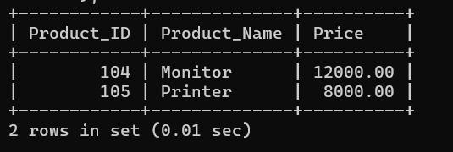

4. Incorrect Natural Join (Relational Algebra)

Incorrect:
Student &Course

Correct:
Student & Student.CourseID = Course.CourseID Course

Explanation:
- Specify the common attribute for joining.
- Prevents incorrect or Cartesian results.

OUTPUT :
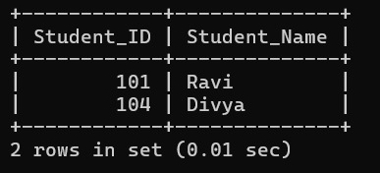

5. Referential Integrity Violation

-- Incorrect
INSERT INTO Student(StudentID, CourseID)
VALUES (101,500);

-- If CourseID 500 does not exist, it violates Foreign Key.

-- Correct

CREATE TABLE Course(
CourseID INT PRIMARY KEY,
CourseName VARCHAR(50)
);

CREATE TABLE Student(
StudentID INT PRIMARY KEY,
CourseID INT,
FOREIGN KEY (CourseID)
REFERENCES Course(CourseID)
);

INSERT INTO Course VALUES(500,'DBMS');

INSERT INTO Student VALUES(101,500);

Explanation:
- Insert parent record first.
- Enforce FOREIGN KEY constraint.

OUTPUT :
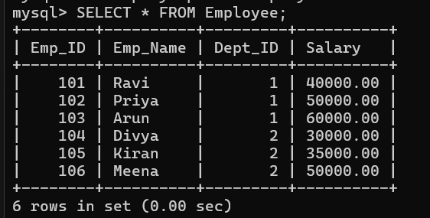

6. Replace Nested Query with JOIN

-- Inefficient Query
SELECT StudentName
FROM Student
WHERE CourseID IN
(
SELECT CourseID
FROM Course
WHERE CourseName='DBMS'
);

-- Optimized Query
SELECT s.StudentName
FROM Student s
INNER JOIN Course c
ON s.CourseID=c.CourseID
WHERE c.CourseName='DBMS';

Explanation:
- JOIN is faster and easier to optimize than nested subqueries.

OUTPUT :
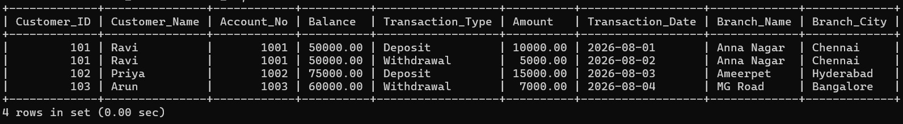

7. GROUP BY Produces Wrong Result

-- Incorrect Query
SELECT DepartmentID, StudentName, AVG(Marks)
FROM Student
GROUP BY DepartmentID;

-- Correct Query
SELECT DepartmentID,
AVG(Marks) AS AverageMarks
FROM Student
GROUP BY DepartmentID;

Explanation:
- Every selected column must either be aggregated or included in GROUP BY.
- StudentName cannot appear without aggregation.

OUTPUT :
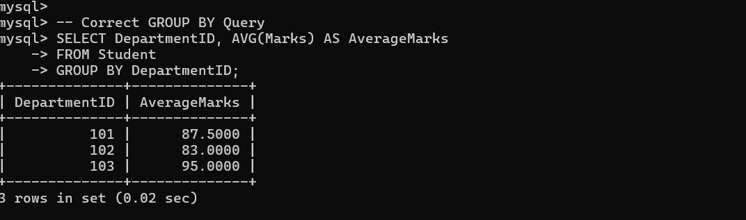

8. UPDATE Statement Modifies All Row

-- Incorrect
UPDATE Student
SET Marks=100;

-- Correct
UPDATE Student
SET Marks=100
WHERE StudentID=101;

Explanation:
- WHERE clause limits the update to the intended row.
- Without WHERE, every row is updated.

OUTPUT :
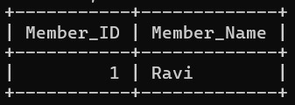

9. Optimize Multi-table Query

-- Inefficient Query
SELECT StudentName
FROM Student
WHERE DepartmentID IN
(
SELECT DepartmentID
FROM Department
WHERE Location='Chennai'
);

-- Optimized Query
SELECT s.StudentName
FROM Student s
INNER JOIN Department d
ON s.DepartmentID=d.DepartmentID
WHERE d.Location='Chennai';

-- Recommended Indexes
CREATE INDEX idx_student_department
ON Student(DepartmentID);

CREATE INDEX idx_department_location
ON Department(Location);

Explanation:
- JOIN improves readability and performance.
- Indexes speed up searching and joining.

OUTPUT :
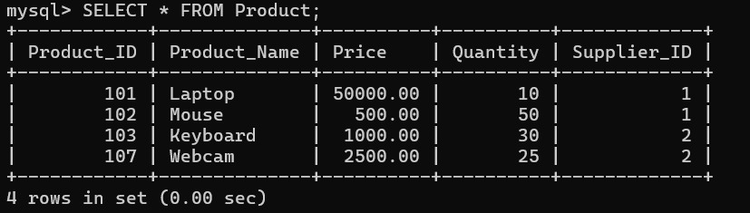

10. Relational Calculus Quantifier Error

Incorrect:
{ s | ∀c (Course(c) → Enrolled(s,c)) }

Correct:
{ s | ∃c (Course(c) ∧ Enrolled(s,c)) }

Explanation:
- Universal quantifier (∀) requires the student to be enrolled in every course.
- Existential quantifier (∃) correctly returns students enrolled in at least one course.

OUTPUT :
